LIGHT DUTIES PROFORMA - POST COVID RECOVERY PATHWAY (MINIMUM 28 DAYS)

 | Surname | Surname |  | Initials | Forenames |  | Rank | Rank/Title
 | Unit | Organisation Name |  | Sub-unit | Sub Unit |  | Number | Service Number

Current Disposal:
Fit for Limited Duties, duration 28 days

Rank/Title Surname is required to adhere to the Post Covid Recovery Pathway (PCRP) for a minimum of 28 days from release from isolation / symptom resolution (whichever is earlier).

The PCRP is divided into blocks where levels of physical activity are defined by Rating of Perceived Exertion or 'RPE'. Commanders should use the scale below to guide training activity signpost to Platoon PTIs for planned PT sessions.

If at any point Rank/Title Surname reports worsening shortness of breath, chest pain or excessive fatigue, please seek medical input.

Please visit https://www.yourcovidrecovery.nhs.uk for further information on how to support recovery from Covid.

Med Comments: Free Text Prompt

Planned Review: Submit an eConsult if symptoms have not resolved by day 26-28, otherwise return to normal duties.
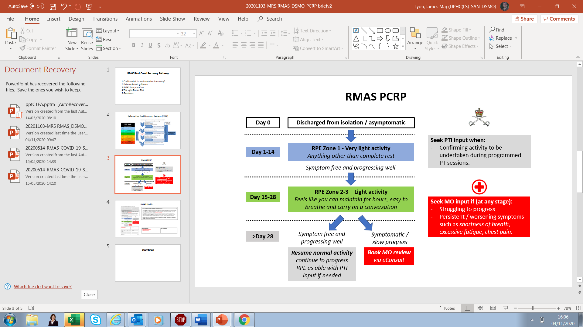

 | Name | User Name |  | Rank | User Title |  |  | Unit stamp
 | Signature
 | Post |  |  | Tel no. |  |  |  | Date | System Date

Guide for individuals and Commanders:

Weeks | RPE | What sort of phys is appropriate? | What is appropriate Exercise activity? | INDIVIDUALS:  How do I know if I am doing too much? | TRAINING STAFF:  How can I tell if an activity is appropriate?
1 and 2: | Zone 1 | Rest and stretching, yoga, pilates. | Observational / CP work.  Not sleeping out in field. | You should not be doing anything especially physically active.  If you feel fatigued this is a sign you need to rest more. | Activity in this block should be just above complete rest, such as observational activity and stretching.  Any active physical participation in training serials is likely to be too much.
3 and 4: | Zone 2-3 | Very light CV activity you can easily sustain for hours ie:  - Turning legs over on Wattbike)  - Longer walks without weight | If tolerated:  - Marching in CEFO  - Sleeping in the field  - Following behind section attacks but not participating in deliberate actions. | You feel fatigued / short of breath during an activity.  Unable to hold a conversation at length. | Deliberate actions on exercise serials should be viewed as a red line.  No evidence of increased effort of breathing and able to hold a conversation at length.

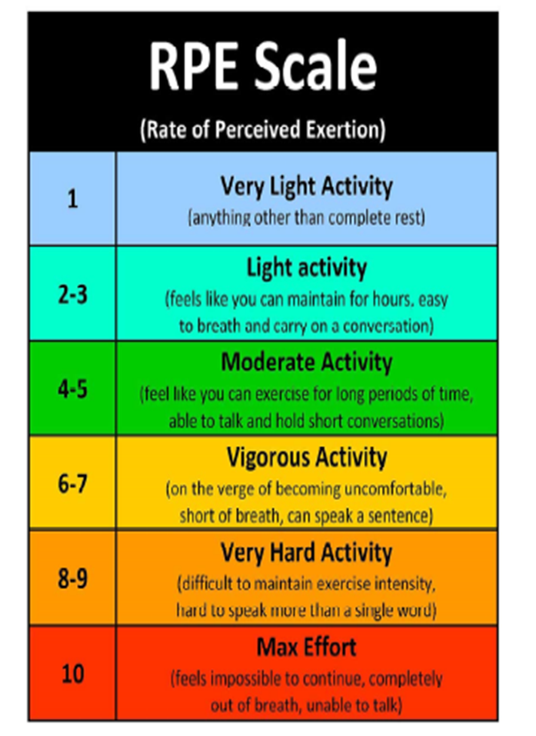

Service Occupational Divers are UNFIT diving until assessed by a diving doctor (DRI 14/20 refers).

Aircrew and Controllers need a MAME review, with single service Aviation Medicine input, prior to returning to flying or controlling.

